SEL751 Unit Test Model Documentation v1.0

Abstract

This document specifies the model details for a unit test of the SEL-751 relay (751#1098594) interfaced through a Typhoon HIL Connect for C-HIL testing.



Table of Contents

1 Model Details and Diagram 2

1.1 Model Settings 2

1.2 Model Internals Diagram 3

2 Model Description 3

3 Model Specifications 3

3.1 Model Initialization 3

4 Interfacing Information 4

4.1 Controller Hardware: 4

4.2 Controller Interfacing 4

4.3 Controller Firmware 4

4.4 Controller Settings 4

4.5 Model Inputs 5

4.6 Model Outputs 5

5 Model Validation 5

5.1 Circuit Breaker Close (Downstream source unpowered) 5

5.2 Circuit Breaker Open (Downstream source unpowered) 6

5.3 Circuit Breaker Close (Downstream source powered) 6

5.4 Circuit Breaker Open (Downstream source powered) 6

6 Known Issues 7

7 References 7

8 Revision history 7

# Model Details and Diagram

Model Schematic File: *SEL751 Unit Test v1.0.tse*

Model Settings File: *SEL751 Unit Test Settings V1.0.runx*

Model CUI File: N/A

Required Licenses/libraries: Typhoon HIL Singal Processing Library

Model Symbol:

## HIL Setup

HIL Hardware Serial Number: 00603-00-00025  
HIL Firmware: *HIL603_161217_c1.tfwx*

HIL Software Version: 2016.4

## Model Settings

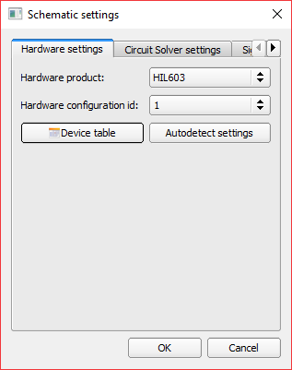 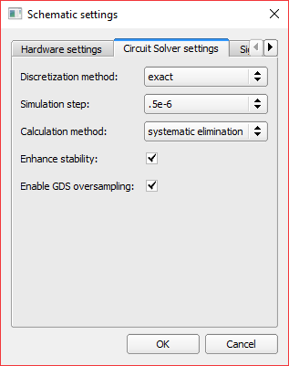 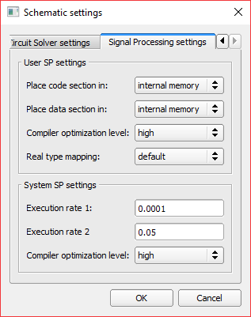

## Model Internals Diagram

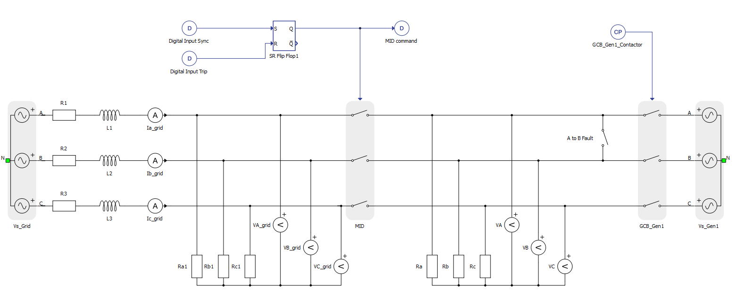

# Model Description

This is a unit test interface model to a Schweitzer Engineering Laboratories SEL-751 relay controller.

The model simulates a three-phase circuit breaker which is controlled by a physical SEL-751 relay controller.

The model uses the digital output commands trip and close from the SEL-751 relay controller to control the 3-phase circuit breaker using digital inputs on the HIL. The upstream voltages and currents are then output from model using analog outputs on the HIL. One phase of voltage is also output from the model downstream from the circuit breaker and is used for sync check functionality.

# Model Specifications

This section specifies the model specification such as initialization, assumptions, limitations, and required parameters.

## Model Initialization

*# Numpy module is imported as 'np'*

*# Scipy module is imported as 'sp'*

*# DSP Execution Rate*

*Ts = 100e-6*

# Interfacing Information

If needed, this specifies the hardware interface, controller firmware, settings, input requirements, and possible outputs.

**It is highly recommended to read the controller manufacturers datasheets and manuals when working with physical controllers to prevent damage to the hardware or injury to the user.**

## Controller Hardware:

|  |  |  |  |
| --- | --- | --- | --- |
| **Name** | **Manufacturer** | **Mfg Part #** | **Notes** |
| SEL-751 | SEL | 751#1098594 | Low Energy Analog Relay Controller |
|  | SEL | 9975LL00 | Sync Check Expansion Module |

## Controller Interfacing

This section describes what is needed to interface with the controller.

1. Host PC with SEL AcSELerator QuickSet software.
2. Ethernet or serial cable for PC to Controller interface
3. Typhoon HIL Connect- SEL 751 Relay Connect with included interface harness (PN: )

## Controller Firmware

This model was tested using the following firmware:

FID: SEL-751-R112-V0-Z006002-D20151112

## Controller Settings

This model used the following settings file:

*SEL751 LL Microgrid Settings v1.0.rdb*

With these settings the SEL-751 will allow the breaker to close under two conditions:

1. When the upstream and downstream voltages and phases are in sync and within tolerance of the settings parameters.
2. When the upstream is in the tolerance of the settings parameters and the downstream is unpowered.

The settings will allow the SEL-751 to open whenever the command issued.

## Model Inputs

|  |  |  |  |  |  |
| --- | --- | --- | --- | --- | --- |
| **Input Name** | **HIL Input Channel** | **Signal Inverted?** | **Data Type** | **Execution Rate** | **Required/ Optional** |
| Digital Input Close | DI5 | True | Unit | 100e-6 | Required |
| Digital Input Trip | DI6 | True | Unit | 100e-6 | Required |

## Model Outputs

|  |  |  |  |  |  |
| --- | --- | --- | --- | --- | --- |
| **Output Name** | **HIL Output Channel** | **Signal Inverted?** | **Scaling** | **Offset** | **Required/ Optional** |
| Ia_grid | AO7 | N/A | 355 | 0 | Required |
| Ib_grid | AO8 | N/A | 355 | 0 | Required |
| Ic_grid | AO9 | N/A | 355 | 0 | Required |
| VA_grid | AO21 | N/A | 3485 | 0 | Required |
| VB_grid | AO22 | N/A | 3488 | 0 | Required |
| VC_grid | AO23 | N/A | 3447 | 0 | Required |
| VA | AO24 | N/A | 3432 | 0 | Required |
| MID_fb | DO3 | False | N/A | N/A | Required |

# Model Validation

This specifies which techniques and evidence were used to validate the model.

## Circuit Breaker Close (Downstream source unpowered)

This test shows the SEL-751 receiving a close command, with the downstream side of the circuit breaker unpowered.

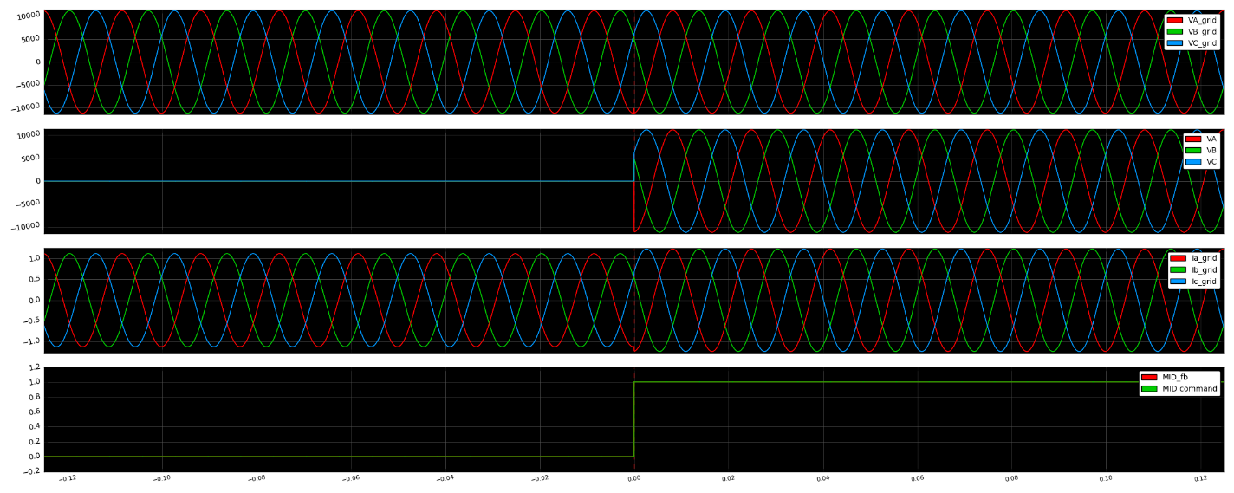

## Circuit Breaker Open (Downstream source unpowered)

This test shows the SEL-751 receiving an open command, with the source on the downstream side of the circuit breaker unpowered.

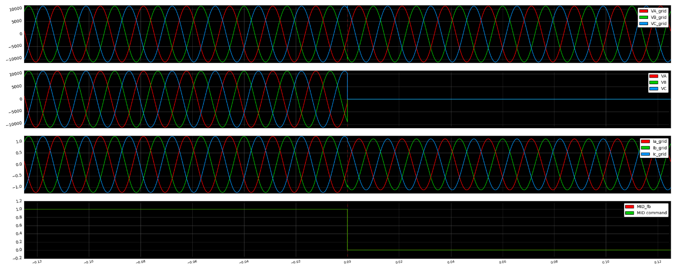

## Circuit Breaker Close (Downstream source powered)

This test shows the SEL-751 receiving a close command, with the source on the downstream side of the circuit breaker powered.

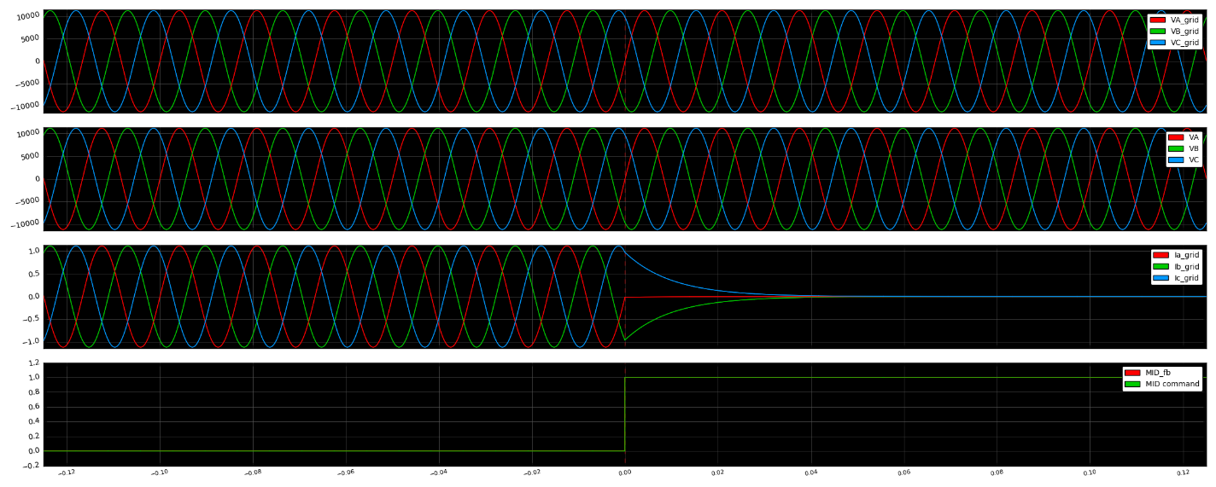

## Circuit Breaker Open (Downstream source powered)

This test shows the SEL-751 receiving an open command, with the source on the downstream side of the circuit breaker powered.

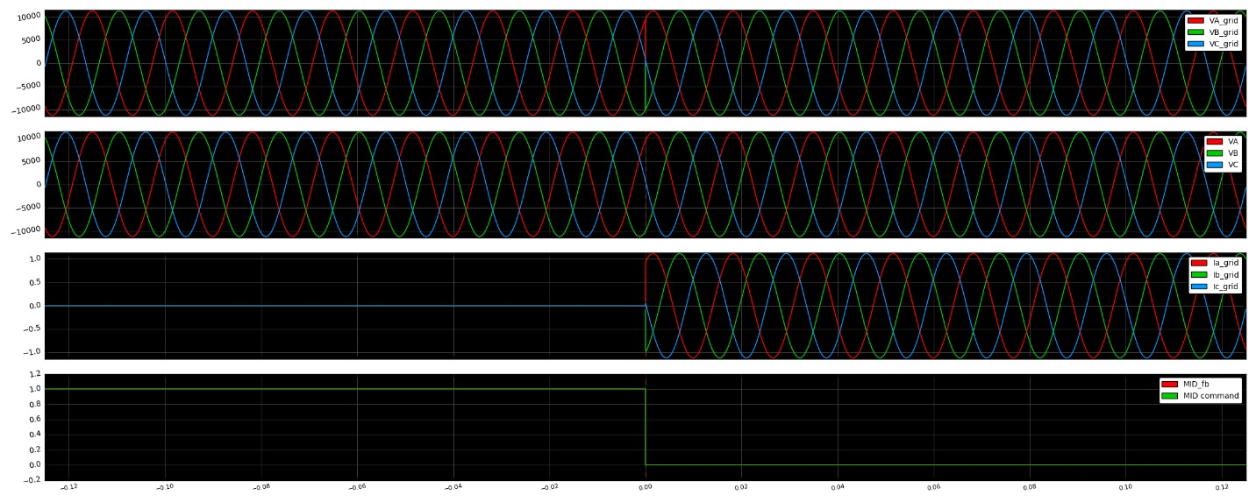

# Known Issues

This specifies any known issues with the current version of the model.

1. There are no known issues with the specified model.

# References



# Revision history

|  |  |  |  |
| --- | --- | --- | --- |
| Date | Version | Author | Description |
| 03-23-2017 | 1.0 | Ryan Deyo | Initial release. |
|  |  |  |  |
|  |  |  |  |
|  |  |  |  |
|  |  |  |  |
|  |  |  |  |